SSA / SST - Space Situational Awareness / Space Surveillance and Tracking by

ALOMAR Observatory

Pre-study: Development of a camera based SSA/SST utility

and corresponding software

Summerschool internship report

Niels Stefanski

September 23, 2022



**1 Introduction**

The aim of this pre-study was to develop a camera-based SSA/SST system with corresponding software that allows to identify orbiting objects like for example satellites or space debris and to determine their position precisely. Within the scope of the project, a suitable 2-axis tracking gimbal for a secondary tracking camera should be selected and tested and possible limits should be evaluated. This gimbal system should be inexpensive (also with respect to replacement parts) and easy to use for applications with other cameras. Already available on-site was the ALOMAR allsky camera which ideally should be incorporated in this approach and upgraded by a second gimballed camera system.

For this purpose, a software is required that is able to identify a satellite on the night star background. Two main aspects have to be taken into account: Firstly, the software must be able to identify also small objects with low visibility on the night sky which requires specific software filter systems, and secondly, the software must be able to position the satellite in the 3D space by perspective reconstruction using satellite traces in a long exposure image.

**2 Camera selection**

The outcome of any satellite tracking study is mainly dependent on the choice of the camera, the available datasets and a few other important issues which should be considered when working with satellite image, as will be discussed in this section. During the development of the detection software prototype in this study it turned out that the accuracy of the satellite tracking software is heavily dependent on the camera selection.

Due to the time of the year, the dataset that was used for the development did not primarily come from the ALOMAR allsky camera. Instead, data sets from several other cameras (ranging from GoPro images to images taken from a camera with a fisheye lens similar to the allsky camera) were used. The availability of different data sets from several camera types proved to be helpful in selecting the preferable characteristics for the camera, especially as it was possible to compare the usability of different detection camera set ups to the ALOMAR allsky camera.

**2. 1 Suitability of the ALOMAR allsky camera**

As mentioned above, the main dataset in this study was not generated with the ALOMAR allsky camera because very little data was available due to the time of the year. Most of the previously made images were either for cloud or Aurora imagery and taken under conditions under which satellites would not show up as sky traces in the image. The few test images that could be taken with the ALOMAR allsky camera however indicated already that the allsky camera in its current configuration might not be the best choice as primary detection camera for the intended application.

The allsky image is cropped to fit a round image of a 180° view-angle which results in each pixel covering a large area of the sky. The more area a single pixel has to cover, the lower are resolution and light sensitivity. Most satellite traces are very thin and dim (see also item 3.3 Satellite detection) and thus won't be detected if the trace is smaller than a pixel in the image. Another problem is that noise gets even more disturbing if the resolution is low. For comparison: a single pixel of the allsky camera covers on average 168 arcseconds, while the images from the camera for the test datasets used in this study had 70 arcseconds per pixel on average with a viewing angle of 100° degrees.   
Generally, a 180° viewing angle is not absolutely necessary when trying to optically position satellites. Firstly, most satellites are not visible in the lower parts of the sky (close to the horizon, approx. 20° in elevation) since these satellites are too far away. Secondly, if the stationary part of the ALOMAR allsky camera is used for satellite detection, areas close to the horizon are highly distorted (which is the case for most lenses of allsky cameras). Both factors lead to very poor data from the lower parts of the sky.

**2. 2 Choice of the detection camera**

Task of the detection camera is to find satellites in the sky and to transmit their sky position to the identification camera (the satellite tracker). The detection camera should thus provide an overview of the whole sky so that the tracker can subsequently make magnified follow-up shots of the satellites for more accurate satellite identification. As previously discussed it is not required to have a camera covering 180° like the allsky camera. A camera with a lens covering a viewing angle of 110 to 140° proved to be a very good compromise between resolution and detection area which means that standard camera lenses could also be used for the main detection camera. Due to their high resolution, full-frame sensors are a good choice to capture smaller satellites and debris; furthermore desirable is a high light sensitivity.

The Sony Alpha 7 III provides all the preferred features for a detection camera with respect to a full frame sensor and very high light sensitivity. Another advantage is that the Sony Alpha 7 III is already standardly used for the ALOMAR allsky camera.

**2. 3 Choice of the tracker camera**

The tracker- or identification camera is mounted on a gimbal system (see also item 4). This camera is intended to have optical magnification in order to position the satellites more accurately. The tracking gimbal is designed to carry standard sized DSLR cameras or similar, but other options are possible as well. For the development of the tracker prototype in this study it should be kept in mind that the entire device is generally only suitable for inside use since neither the tracker nor the recommended cameras would withstand the harsh weather conditions at the ALOMAR without damage.

The best option would be to use the same standard camera as previously mentioned for the identification camera, but with a different lens setup. As also for the detection camera, both high light sensitivity and low noise is desired, but it is not necessary to have a full frame sensor in this case. Even though still advantageous after magnification, a bigger sensor would probably not be of much benefit, and that is the reason why also cheaper options could be used. An alternative would be to use something like the Raspberry Pi camera sensor with a mount for lenses. This sensor has a very high resolution and is very cost effective. There are other options for the Raspberry Pi sensor with standard C camera mounts so that different lenses can be fitted.

**3 Satellite tracking software prototype**

This section explains the parameters of the prototype for a satellite tracking software for ground based camera systems that are able to automatically detect satellites and calculate their orbital parameters. Camera calibration, background star identification, positioning methods and calculation of their position in space will be discussed in more detail. The considerations in the following specifically apply to stationary cameras like the allsky camera, but sometimes also gimballed cameras (satellite tracker) are referred to as later mentioned.

**3.1 Camera calibration and coordinate transformation**

An essential step for optical tracking systems is the camera calibration, the calculation of the distortion parameters caused by the lenses, and the subsequent translation of the image coordinates into horizontal coordinates. For camera calibration, different methods can be applied which either calculate the lens distortion mathematically or use e.g. known stars in the sky as reference. The interference of the allsky camera's lens distortion and the dome's refraction however make a mathematical distortion calculation nearly impossible because the dome's refraction changes every time the camera is moved with the wrench system the allsky camera is attached to.

For this investigation, a star-based calibration system using the night sky as a reference proved to be superior with respect to low calibration time or simplicity and also accounts for the lens-dome interference. Here, a calibration based only on a single input image was used because the allsky camera is frequently moved while testing. Any calibration method needing several input images would have increased the calibration time considerably. Even though the single image method is slightly less precise, it is still sufficient to provide accurate calibration data for the first prototype tests. Thus it was confirmed that the calibration method in general provides the desired results, even though higher precision might be achieved by other calibration methods like e.g. 2D-fitting.

The next step was to embed the calibration procedure in a user interface so that anyone without broad background knowledge can use this system. In addition to increased user accessibility, the calibration time is reduced. This single image calibration procedure is generally suitable for any stationary camera and not restricted to the ALOMAR allsky device. This system will output calibration data for the camera, the distortion parameters as a third degree function, as well as the parameters to transform image into horizontal coordinates. The parameters are the position of the sky’s zenith (azimuth = 0°, elevation = 90°) in the image, the cardinal direction the camera is facing (north vector), and the value for the area a pixel covers in the sky (arcseconds/pixel).

There are other methods for coordinate transformation which don’t require a calculation of the lens distortion or transformation parameters. Most likely it's more accurate to use a 2D-fit which wouldn’t need approximation methods like used in Figure 1. This 2D-fit would relate every pixel directly to a sky position when trained on manual input stars.

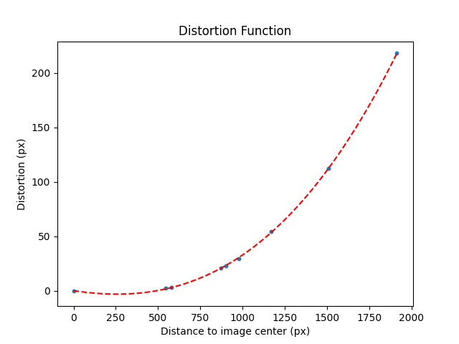

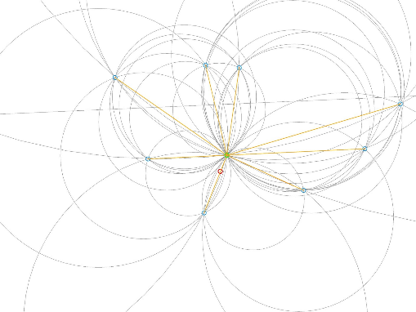

Figure 1: (a) Calculated distortion function (b) Alignment of the zenith using input star positions

Calibration method (b) calculates a very precise approximation for the distortion of the camera lens and the zenith position in the image. The particular method delineated in (b) uses inscribed triangles between the stars to find the zenith. With the zenith position it is possible to calculate the lens distortion (a) at each star position and fit a function to get the distortion parameters.

**3.2 Star detection and identification**

The star identification serves two purposes: the main reason is the usage for satellite positioning as discussed later. Furthermore, it serves to increase the accuracy of the calibration using the newly identified stars as calibration data, either by implementing a regional error correction or running the calibration with the new dataset.

The algorithm for the detection of stars is a really important factor for the subsequent star identification. I have adjusted the star detection filters and algorithms such that I am not detecting the maximum possible number of stars. First tests showed that more errors in the matching of stars occur if the parameters for detection are too sensitive. The matching is most accurate when there are as many calculations from the database as there are image-detected stars.Star identification was in this study performed by calculating the horizontal coordinates of thousands of stars from a database, followed by transforming the detected starcoordinates in the image into horizontal coordinates. It is thus possible to match the stars from the database to the image coordinates. If a star in the database and the image have identical coordinates, they are identified as the same star (Figure 2).

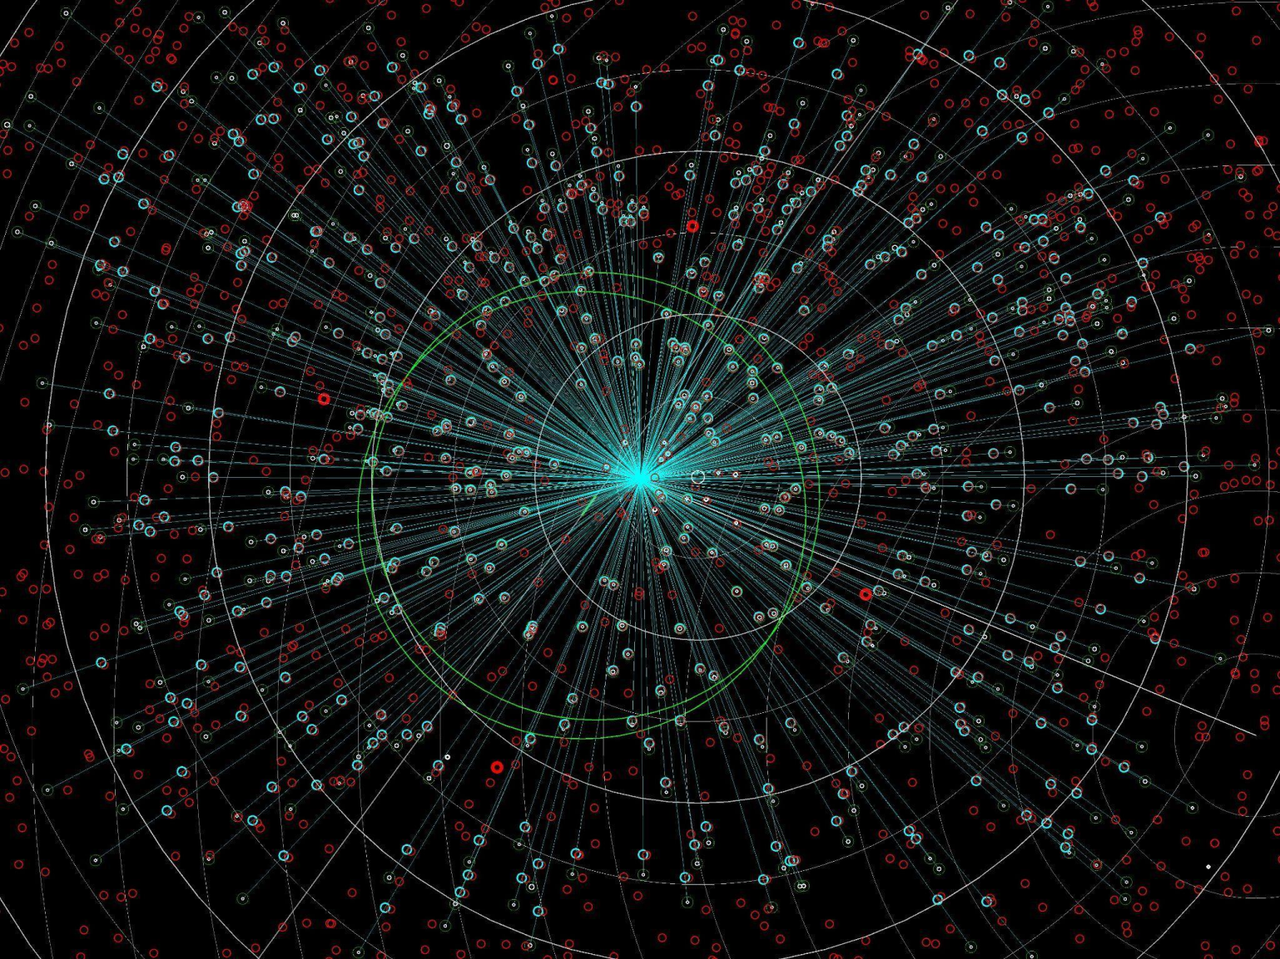

Figure 2: Star identification. Red circles indicate the star positions as calculated from the database, white dots are the detected stars in the image, and blue circles show the undistorted star positions if the star was identified.

In this test, 496 stars were optically detected in the image and 484 of them were successfully matched. The error in this test was on average 0.3 px with respect to the distortion and on average 3 px by misalignment of the zenith or the north vector. These values are generated from an image of 4000x3000 px and 100° viewing angle.

The apparent magnitude at which the camera and the star detection are able to recognize stars was approximately 6.4, which means for reference that the software is able to successfully identify all stars that the human eye can recognize. The system is however not limited to stars visible to humans; with better cameras the system would be able to detect more stars. All red circles are calculations up to magnitude 6.7 where no star is recognized by the camera, but the calculation would find them if the camera would have picked them up.

Of high importance for the outcome is the precise timing of the camera (i.e. the time stamp when the picture was taken), because the calculation of star positions is directly dependent on the time the image was taken. As it turned out in the test, the time stamps provided by the camera were not always exact since the metadata of the images are not designed to capture the time exactly to the second. Recommended is thus to have cameras with clocks that synchronize via the internet or to use the time stamp from the Raspberry Pi or similar.

**3. 3 Satellite detection (optical)**

Satellite detection is the first step in the identification of a satellite and methodically completely different from the detection of stars because completely different filtering systems have to be used. If an object in the image is interpreted as satellite or not can be defined by the respective parameters selected for detection. Generally, long exposure images are advantageous since bright moving objects will leave a trace in the image which can be detected by simple line detection algorithms. In addition to satellites, these algorithms will also detect planes and asteroids, but these objects can be filtered out easily due to their different properties with respect to speed and visual appearance.

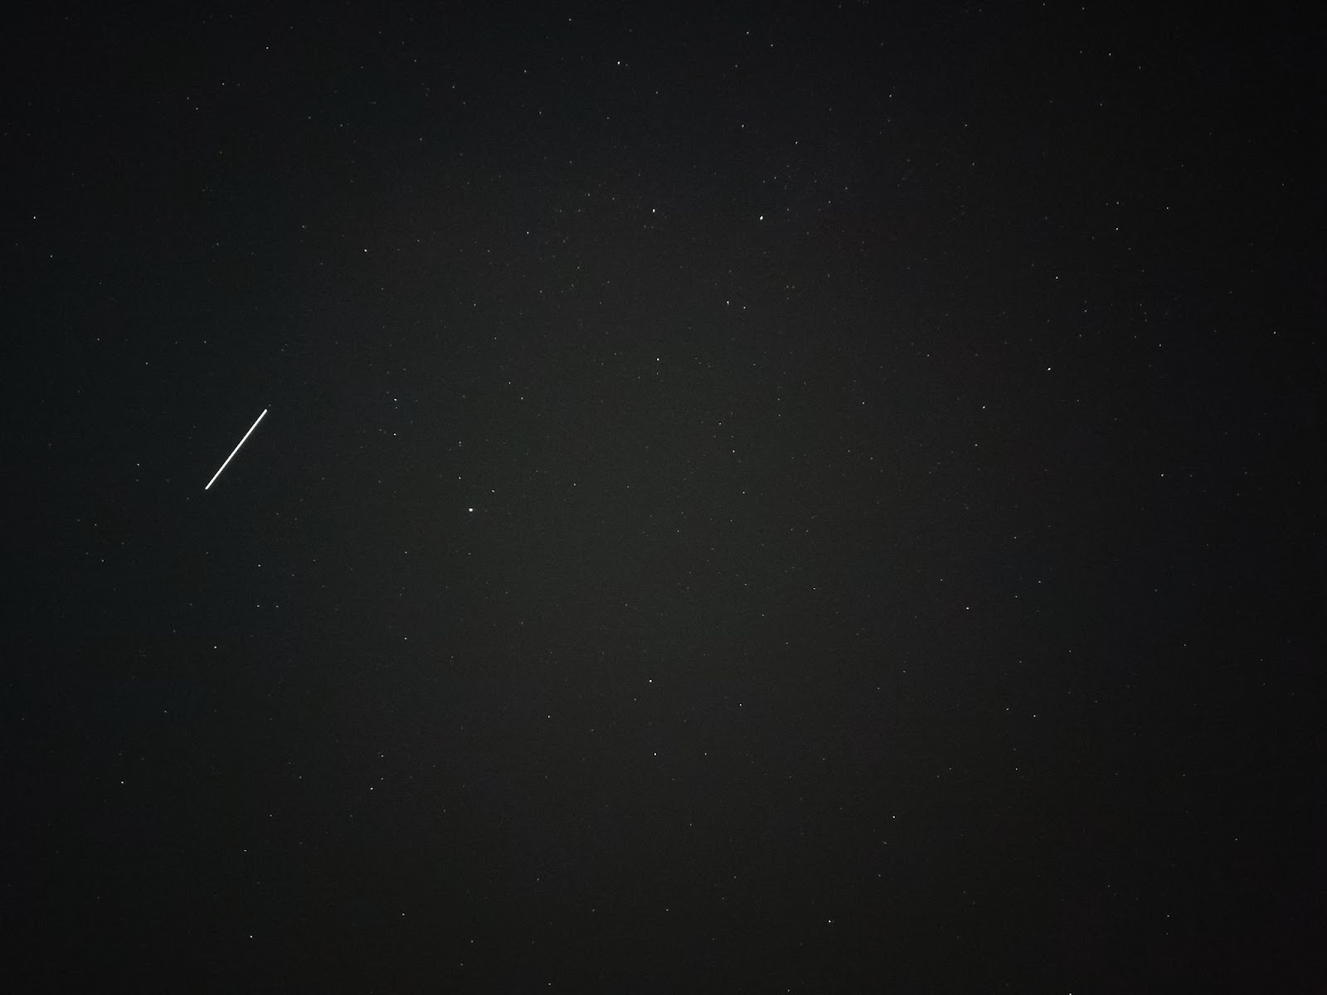

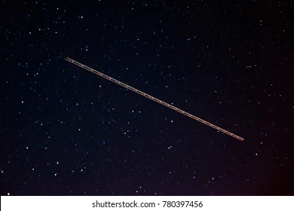

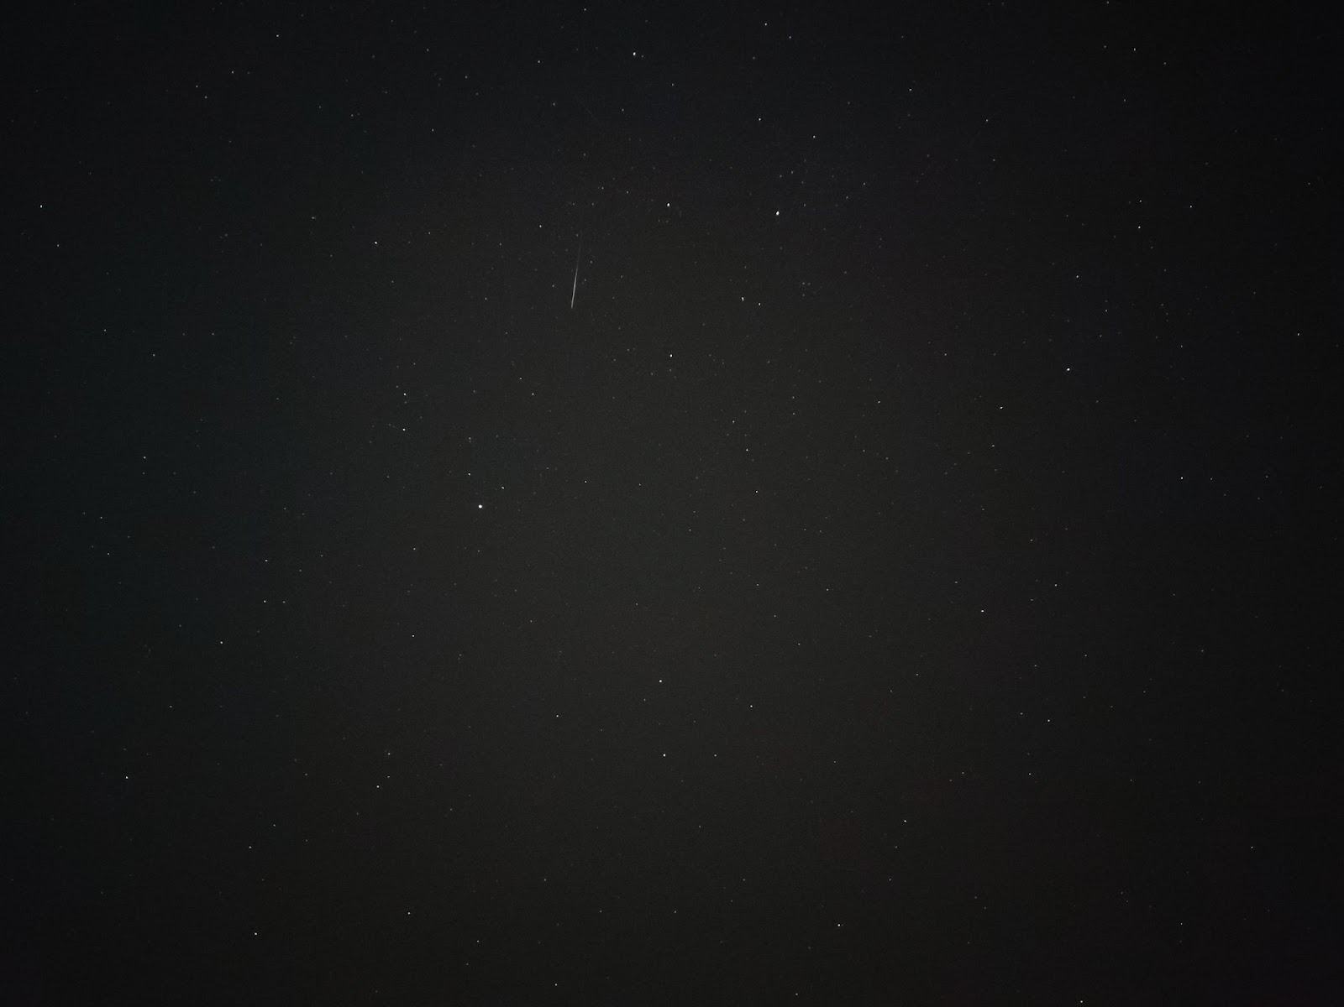

Figure 3: (a) Satellite (b) Asteroid (c) Plane

Satellites will differ in their appearance depending on how high they fly or how much light they reflect. Generally, the visibility of a satellite is highly dependent on the altitude, relative position of sun, earth and satellite, the general albedo of the satellite, as well as the angle the solar panels or reflective surfaces of the satellites are oriented. That means not all satellites passing over the observer are visible, and, if visible at all, the satellite will often appear in a small area of the sky only.

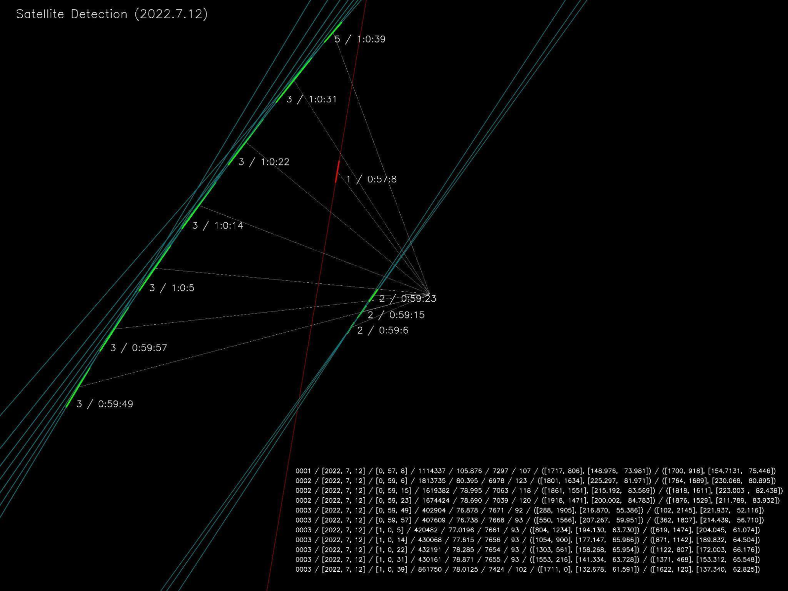

Figure 4: Time lapse satellite detection.

Object 1 is the asteroid seen in Figure 3 (b). The satellite with index two is the most common satellite which is only visible on a small area of the sky. Satellite 3 (see also Figure 3 (a)) is a very low orbiting satellite that is visible throughout most of the sky.

Most satellites are not as bright as shown in Figure 3 (a); they are not visible to the human eye and difficult to detect even in long exposure images. The trace of moving objects will always be less bright than that of stationary objects, which is one of the reasons why the length of the exposure time is very important for the visibility of satellite traces in the image. Using different filter steps it is possible to detect these satellites, but the detection is very sensitive and has to be adjusted to different lighting conditions.

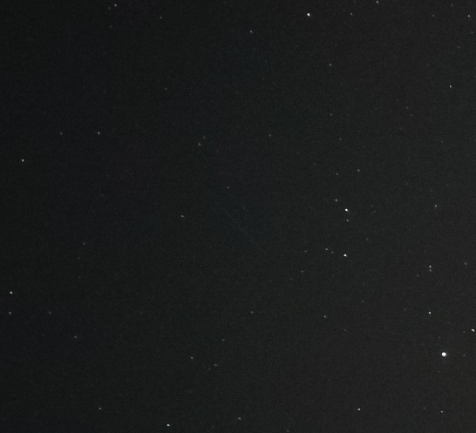 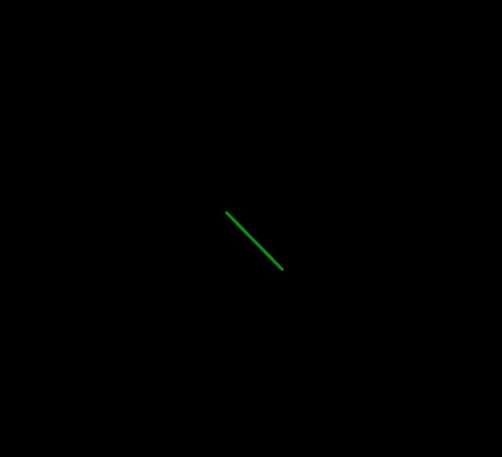

Figure 5: (a) Original satellite image (b) Extracted satellite

This filter test was just exemplary; this filter sensitivity usually produces more error than accurate data. In the tests, only approximately one third of the output were really satellites. The problem is the noise distribution over the image. The sensor is capturing light close to the camera's sensor center brighter and with more noise than in the edges, and thus it is difficult to adjust the filter settings because the sensor does not pick up light evenly.

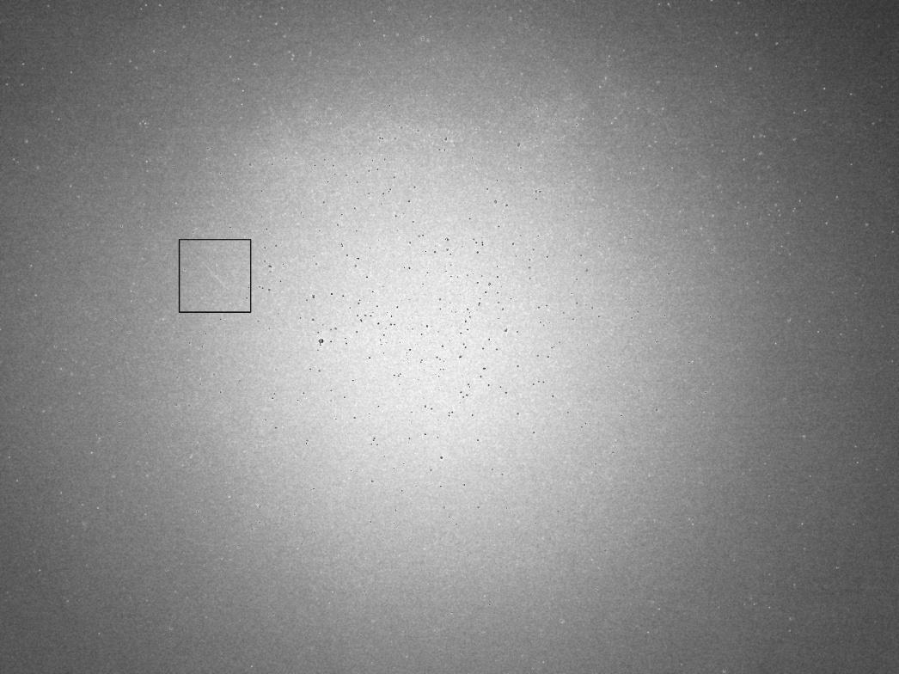

Figure 6: Amplified long exposure image (noise). Square: satellite from Figure 5 (a)

The satellite in the square indicated above is the satellite from (a). Simple line detection has problems finding the satellite because the center of the image is brighter than the satellite itself. In this case, the object cannot be detected by finding the brightest objects in the image. When trying to denoise the image, the trace of the satellite will get weaker or lost because random noise and satellite show similar properties. Filter systems thus have to be carefully adjusted.

**3. 4 Satellite positioning (horizontal coordinates)**

The satellite positioning is the process of translating the image coordinates of the satellite to sky coordinates. Two methods of translating the coordinates are commonly used: either utilizing the calibration or the background stars as reference positions.

When the calibration is used for the translation between the coordinate systems, each pixel in the image is related to sky coordinates. The positioning of the satellite is thus directly dependent on the accuracy of the calibration of the camera. This method is suited for fixed stationary cameras like the ALOMAR allsky camera or similar devices. In my opinion, here the previously mentioned 2D-fit for translating coordinates provides the best results. If cameras on a gimbal system like the satellite tracker are used, it is not is possible to use the same calibration method. The calibration method can however be adjusted to some extent for gimballed cameras, but the results will in this case be less accurate than a background star-based system, because the calibration is heavily dependent on the accuracy of the hardware of the tracker.

The other method is to use previously identified stars as reference points for positioning a satellite to correct for calibration errors. When a star is identified, we know its exact position in the image and the sky. Using vectors it is then possible to position the satellite relative to the background stars. This method is mostly independent of errors caused by miscalibration as long as the stars were correctly identified. Therefore, the method should theoretically be very accurate. I tested this approach by trying to position identified stars, but I did not yet achieve the desired accuracy. The system I implemented translated the position with ± 0.1° of accuracy, but sometimes also larger deviations of ± 1° were obtained which is probably due to an error in the coordinate transformation code.

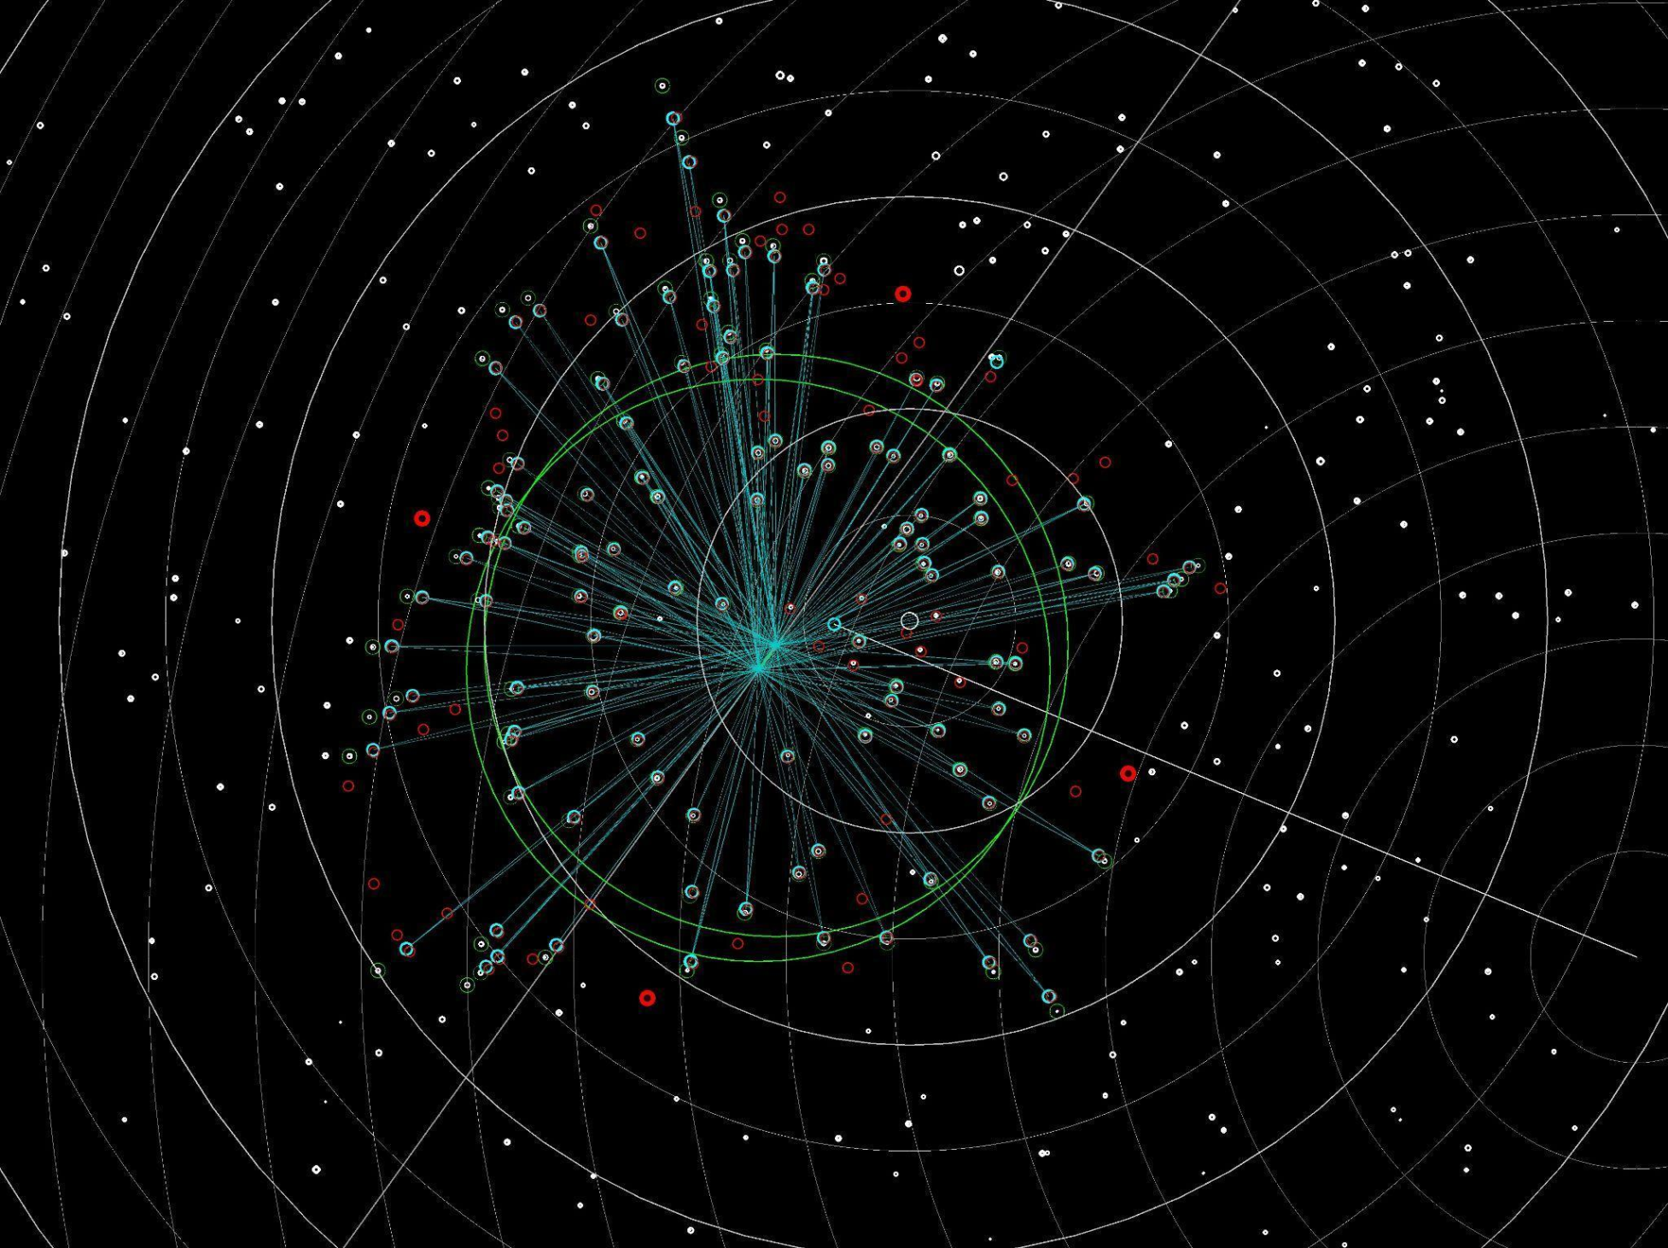

Figure 7: Background star satellite positioning

The above described algorithm positions the start and endpoint of the satellite trace using close background stars. All stars inside the green circles (Figure 7) are used for positioning. For higher accuracy, positioning at least a third point in the middle of the trace would be desirable, but in this case the way the line detection algorithm works has to be changed.

**3. 5 Satellite identification**

For an identification of satellites, the calculation of the orbital parameters is required. This includes calculating the 3D position of the satellite, its speed and height as well as the heading direction. I did not use the six orbital parameters to simplify the testing procedure since velocity and height are easier to compare.

**3. 5. 1 Perspective view correction**

To be able to extract the speed and height of the satellite from the trace it leaves in the sky, the perspective appearance of the satellite (if it would be closest to the observer) needs to be calculated. A satellite flying towards the observer will show a shorter trace in the image than a satellite with the same speed at its closest point to him. I tested this calculation with a simulation of a satellite in 3D and replicating what the observer would see of the satellite. To test the calculation, I used the data of this simulation. The simulated satellite positions could apparently be successfully reconstructed, and a subsequent test with real satellite images also yielded plausible results.

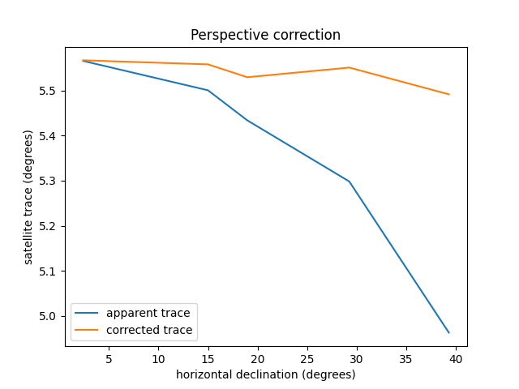

Figure 8: Perspective correction test of consecutive satellite images. The perspective correction calculates how the trace of the satellite would appear at its closest point to the observer. The corrected values are ideally constant, because the satellite is flying at constant velocity.

**3. 5. 2 Orbital calculation**

It is only possible to calculate a satellite's orbit if the eccentricity is close to 1. Height, speed and position were approximated using the length of the corrected trace the satellite spans in the exposure time and its declination at its closest point to the observer.

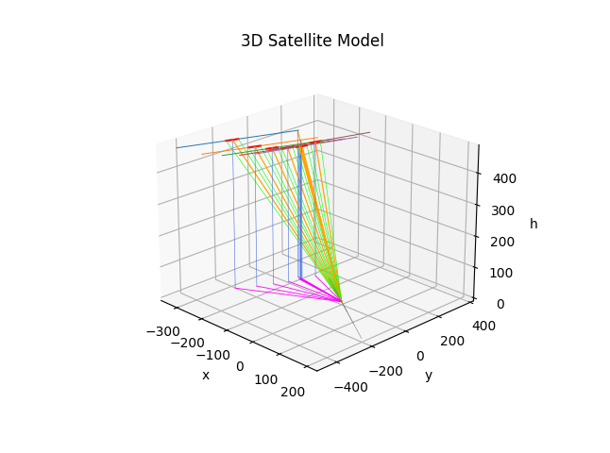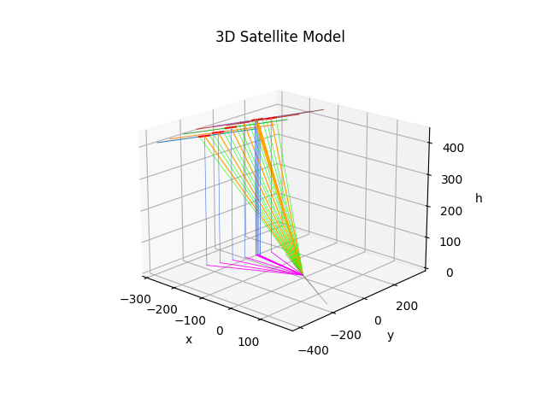

Figure 9: (A) Uncorrected Model (B) Corrected model

With the corrected model the satellite can be positioned more accurately with an average variation in height of ± 2.79 %. This error is most likely caused by inaccuracies in the positioning as previously mentioned. To investigate the positioning we would need to have test images of a known satellite like the ISS. I tried to position satellites orbiting higher than 1800 km, which yielded approximately the same accuracy. These data were collected in a database and can now be used to calculate the orbital parameters in order to identify the satellite in a public satellite database. The orbital parameters can be calculated from three known points of the satellite.

**4 Gimballed camera system (satellite tracker)**

The gimballed camera system as mentioned in 3.4 was planned as a secondary camera to the allsky camera. The allsky camera detects satellites in the sky, while the tracker camera then takes precise magnified follow-up shots which are used to position the satellite more accurately. The current detection and positioning software is designed to perform the calculations of orbital parameters directly from the allsky images, but this will be unnecessary if the tracker camera is working. The allsky camera will in this case only pass on general sky coordinates to the tracker camera. The tracker camera then makes images of these areas where more accurate calculations can be performed. This approach has however one drawback: only one satellite at a time can be recognized.

**4. 1 Tracker gimbal manufacture**

The main design requirements for the tracker gimbal were compatibility with standard-sized reflex cameras, full range of motion with two axes, fast producibility and the availability of replacement parts. For these reasons, a 3D-printed tracker was the best solution for the prototype, especially since already several print files of 2D camera gimbals are available as open source projects. Manufacturing the tracker by 3D-printing instead of buying a commercially available 2-axis gimbal considerably reduced the cost of the project and simplifies the control of the two cameras and tracker at the same time by the software.  
The electrical layout of the tracker uses two Nema 17 stepper motors, controlled either directly by the Raspberry or an Arduino. There are either Hall effect sensors or limit switches for calibration and safety intended.

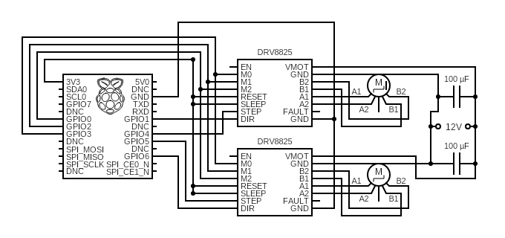

Figure 9: Electrical layout without kill switches or calibration sensors

The accuracy of the tracker movement couldn’t be tested e.g. on night sky images, but the tolerances of the 3D prints are very accurate and, using microstepping, the accuracy should be sufficient for using the motor positions as reference for the matching of stars as described below. For the first tests, I did not include sensors for the calibration of the camera, but for later use, the camera needs to be able to be calibrated automatically. The design includes space for Hall effect sensors.

**4. 2 Tracker gimbal safety and redundant safety system**

A major factor to keep in mind for the tracker is to assure that the tracker will not damage the cameras or itself if the software of the calibration fails. Due to the gimbal’s small size, not all cameras and lenses will be able to rotate freely without hitting the tracker. That is the reason why either smaller camera lenses have to be used or kill switches need to be installed in case of any software failure.

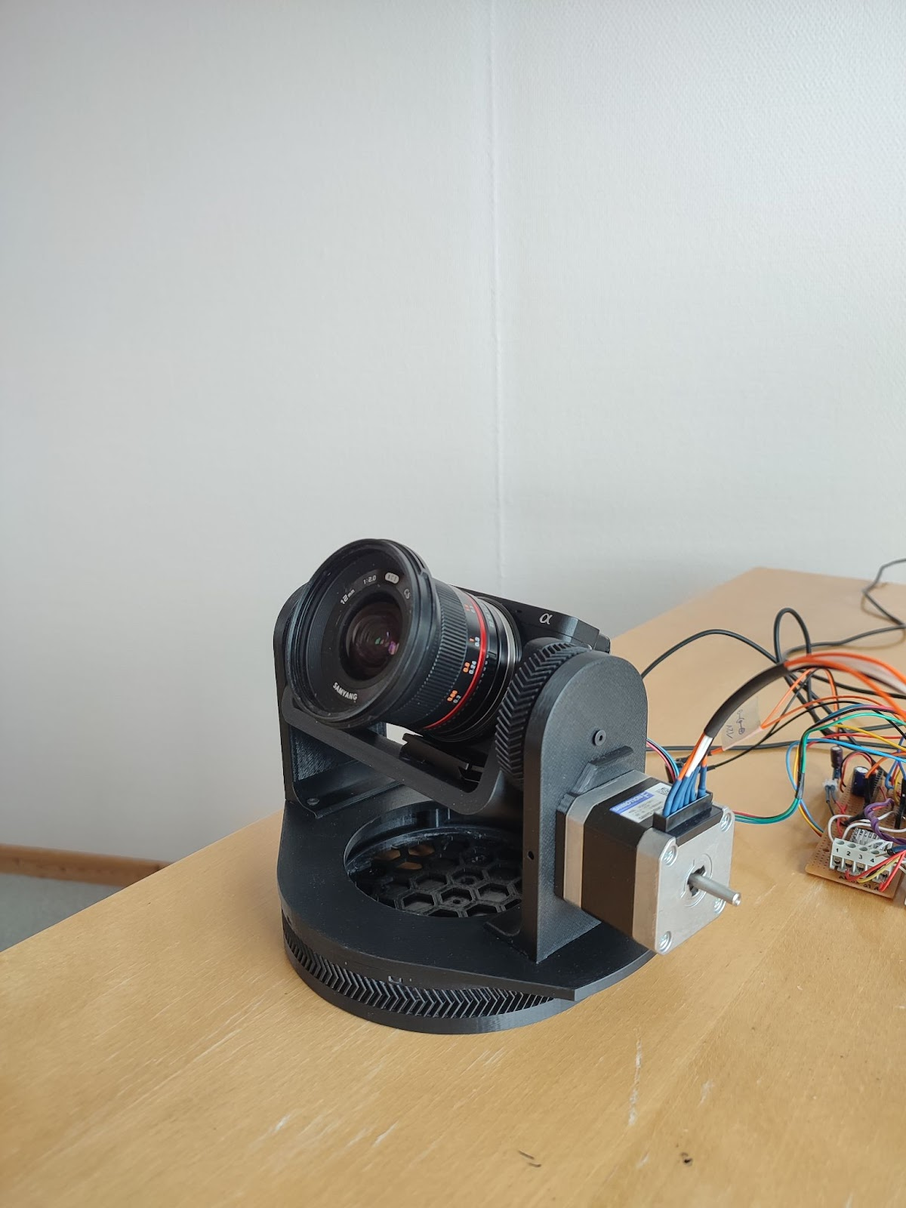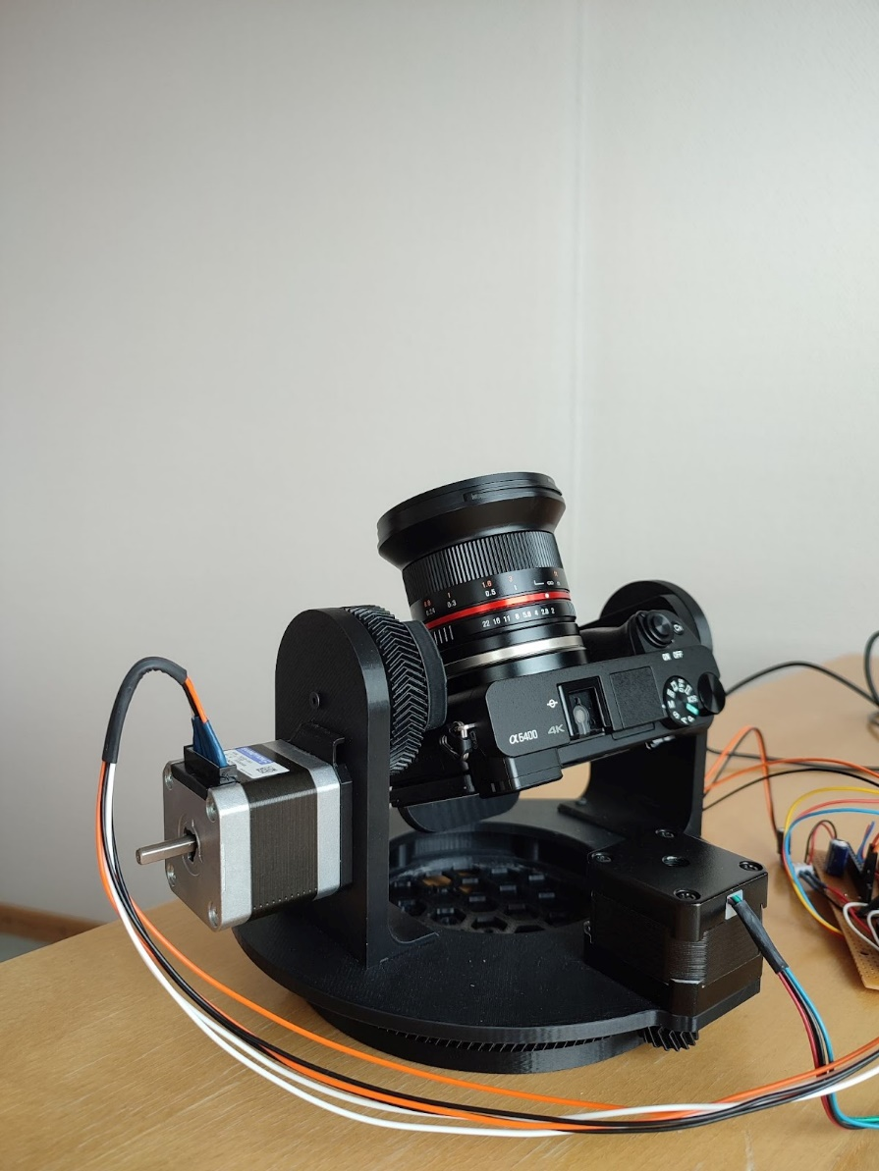

Figure 10: 3D-printed tracker gimbal with test camera

The camera used here was a Sony Alpha 6400 with a Samyang 12mm lens. This camera configuration was able to rotate freely because I used a smaller stepper motor for the azimuth axis.

**4. 2 Camera calibration and star identification**

For accurate positioning it is necessary to have the cameras calibrated. Fixed cameras can be calibrated once and this calibration will approximately always stay the same. The camera of the tracker will need to be partly recalibrated every time it moves because the heading direction of the satellites then changes. The distortion component of the calibration will not change and can thus be calculated from the properties of the lens.

The tracker gimbal has to be calibrated as well which can be done by relating motor positions to the viewing angles (azimuth and elevation). This calibration is a general reference point for the camera direction in order to then relate the background stars to the calculations of stars in that general area. This can be done for example using pattern or template matching, but it is also possible to use simple star matching as described in 3.2.

**5 Conclusion and outlook**

In summary it can be stated that within the scope of this summer internship, a hard- and software prototype of a satellite and surveillance tracking system was developed according to the goals of the pre-study.

* A satellite tracking software primarily for stationary (non-gimballed) cameras was developed, taking into account different aspect like general satellite detection in images, digital filter systems for extracting satellite traces from high noise images, and the calculations for the positioning of satellites in the sky using the identification of background stars and further approximating the 3D position of the satellite and their orbital parameters.
* A basic satellite database was implemented that stores satellite data and checks if they had already been detected.
* A satellite tracker gimbal was selected and 3D-printed. This approach turned out to be cheap, easy to produce and perfectly fit for prototyping and easy testing, but would also meet the requirements and accuracy for further use in the project or later satellite tracking operations.

Nevertheless, the major limitation of the current development state of the project is the camera for the tracker and the current configuration of the allsky camera. Furthermore, the satellite tracking software would need to be tested on more datasets and the calculation needs to be tested on photos of known satellites like the ISS.

The pre-study proved that the optical calculation of the orbital parameters of earth orbiting objects is possible and can be realized with basic ground-based camera systems. In addition, the usage of two cameras (one for tracking and one for higher accuracy identification) showed to be a very promising approach for future investigations.